**DAILY ONLINE ACTIVITIES SUMMARY**

|  |  |  |  |  |  |  |  |  |
| --- | --- | --- | --- | --- | --- | --- | --- | --- |
| **Date:** | **05608/2020** | | | | | **Name:** | **Spoorthy Balaji** | |
| **Sem & Sec** | **6th & B** | | | | | **USN:** | **4al17cs098** | |
| **Online Test Summary** | | | | | | | | |
| **Subject** | | **-** | | | | | | |
| **Max. Marks** | | **-** | | **Score** | | | **-** | |
| **Certification Course Summary** | | | | | | | | |
| **Course** | **Salesforce** | | | | | | | |
| **Certificate Provider** | | | **-** | | **Duration** | | | **-** |
| **Coding Challenges** | | | | | | | | |
| **Problem Statement: Python Program for Find sum of even factors of a number** | | | | | | | | |
| **Status: Solved** | | | | | | | | |
| **Uploaded the report in Github** | | | | | **yes** | | | |
| **If yes Repository name** | | | | | <https://github.com/spoorthybalaji/Daily_Status> | | | |
| **Uploaded the report in slack** | | | | | **yes** | | | |

**ONLINE COURSE**

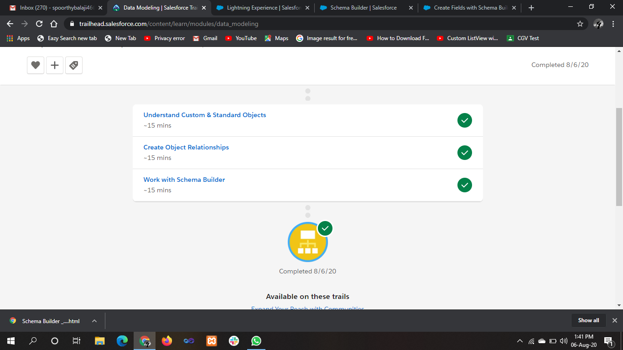

.

**ONLINE** **CODING**

**Python Program for Find sum of even factors of a number**

import math

def sumofFactors(n) :

if (n % 2 != 0) :

return 0

res = 1

for i in range(2, (int)(math.sqrt(n)) + 1) :

count = 0

curr_sum = 1

curr_term = 1

while (n % i == 0) :

count= count + 1

n = n // i

if (i == 2 and count == 1) :

curr_sum = 0

curr_term = curr_term * i

curr_sum = curr_sum + curr_term

res = res * curr_sum

if (n >= 2) :

res = res * (1 + n)

return res

n = 32

print("The sum of even factors is:",sumofFactors(n))

